Operating System Practical Examination (outputs)

1. Implement Round robin scheduling algorithm with quanta 3. Compute waiting time, turnaround time.

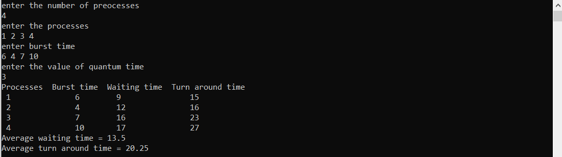

2. Write a program to demonstrate fork where parent and child run same codes and parent process should be executed first.